Jason Walker

Jason.walker@blackpool.ac.uk

App structure

Warehouse Application

Contents

Step 1: Set Up the Project Directory 2

Step 2: Version Control Repository 3

Step 3: Create a New Repository on GitHub 3

Step 4: Upload Python Files to the Repository 3

Step 5: Verify Your Code 3

# Step 1: Set Up the Project Directory

It’s a good idea to create your structure based on a plan

1. **Create a folder** for your project. Let's call it WarehouseApp.
2. Inside the WarehouseApp folder, create 5 Python files:
   * Main.py
   * RegularItems.py
   * InventoryManagement.py
   * BaseInventoryItem.py
   * Sections.py

Open your IDE of choice that supports Python and create new files, I recommend PyCharm <https://www.jetbrains.com/help/pycharm/creating-and-running-your-first-python-project.html#creating-simple-project>  
  
Alternatively, to create the files in notepad, open notepad, click File, click Save As…  
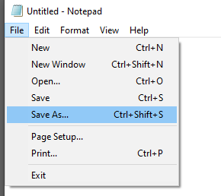

Browse to the desired folder location, type “Main.py” as “File name”

Change “Save as type” from “Text Documents (*.txt)” to “All Files” then click Save.

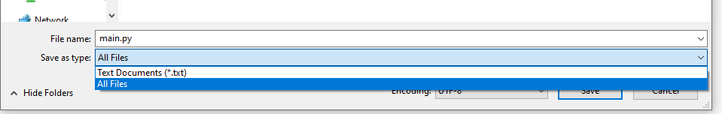  
You can then copy the file and rename each with the relevant name. (File extensions are hidden by default so just type the file name not the extension “.py”  


# Step 2: Version Control Repository

1. Go to [GitHub's website](https://github.com/).
2. Sign up for an account or log in if you already have one.

# Step 3: Create a New Repository on GitHub

1. After logging in, click on your profile picture in the top right corner and go to **"Your repositories"**.
2. Click the green **"New"** button to create a new repository.
3. Fill out the repository creation form:
   * **Repository name**: Enter a name like WarehouseManagementApp.
   * **Description**: Add a description of the project (optional).
   * **Visibility**: Choose between Public or Private.
   * Check **"Add a README file"**.
4. Click **"Create repository"**.

# Step 4: Upload Python Files to the Repository

1. In your newly created repository, click the **"Add file"** dropdown on the right.
2. Select **"Upload files"**.
3. Either drag and drop your Python files (Main.py, RegularItems.py, InventoryManagement.py, BaseInventoryItem.py, Sections.py) into the upload box or click **"choose your files"** to browse and select the files from your computer.
4. After uploading, in the "Commit changes" section at the bottom:
   * Add a commit message (e.g., "Initial commit with inventory management system").
   * Select the option **"Commit directly to the main branch"**.
5. Click **"Commit changes"** to upload the files.

# Step 5: Verify Your Code

1. After uploading, you’ll be redirected back to the repository’s main page.
2. You should now see your uploaded Python files (Main.py, RegularItems.py, InventoryManagement.py, BaseInventoryItem.py, Sections.py).